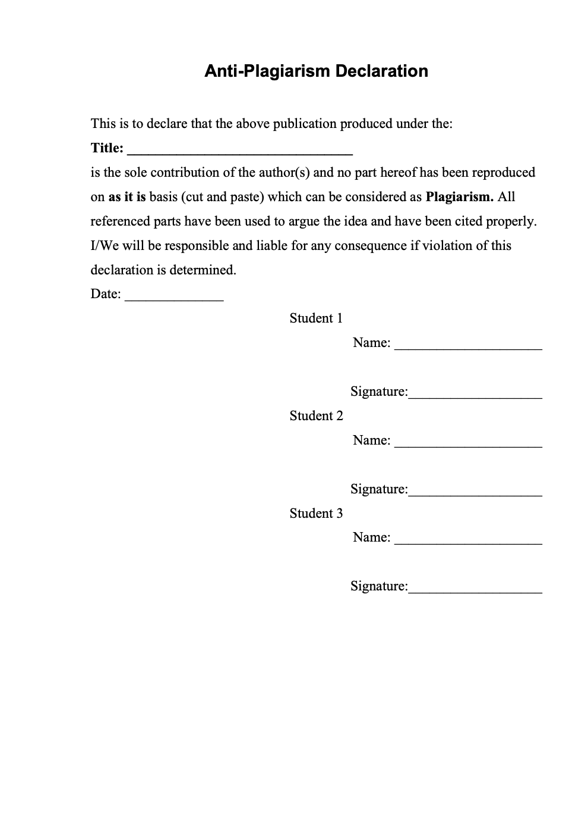

Table of Contents

1. Introduction 5

2. Vision 5

2.1. Problem Statement 5

2.2. Business Opportunity 5

2.3. Objectives 6

2.4. Scope 6

2.5. Constraints 6

2.6. Stakeholder and user description 6

2.6.1. Market Demographics 6

2.6.2. Stakeholders Summary 7

2.6.3. User Environment 7

2.6.4. Stake Holders Profiles 8

2.6.4.1. Supervisors of the project 8

2.6.4.2. Development of the project 8

3. System Requirement Specification 9

3.1. System Features 9

Login 9

Search items 9

Add to cart 9

Payment integration 9

Live chat 9

Newsfeed 9

Ads posting 9

Pet authenticity 9

Hire trainers 9

Animal photography 9

Pet adoption 9

Nearby pet shops 9

Alerts 10

Rent a pet 10

Pet shows 10

NGO’s 10

3.2. Functional Requirements 11

3.3. Non-Functional Requirements 11

3.3.1. Privacy 11

3.3.2. Performance 11

3.3.3. Availability 11

3.3.4. Security 11

3.3.5. Data Integrity 11

3.3.6. Quality 11

4. Use Case Diagram 12

5. High Level Use Case 13

5.1. Manage Users 13

5.2. Login/Signup 13

5.3. Send/Receive Messages 14

5.4. View News Feed 14

5.5. Receive Alerts 15

5.6. Post an Ad 15

5.7. View Pet Shows Info 16

5.8. Rent/Adopt a Pet 17

5.9. Choose Payment Method 18

5.10. Contact NGO 18

5.11. Locate Nearby Pet Shops 19

5.12. Avail Services 19

5.13. Search Item 20

5.14. Authenticate a Pet 20

5.15. Add to Cart 21

6. Expanded Use Case 22

6.1. Login/Signup 22

6.2. Manage Users 23

6.3. Send/Receive Messages 25

6.4. Authenticate a Pet 26

6.5. Post an Ad 27

6.6. Search Item 28

6.7. Choose Payment Method 29

7. Domain Model 30

8. Class Diagram 31

9. Activity Diagram 32

10. Layer Diagram 33

11. Data Flow Diagram 34

12. System Sequence Diagram 34

12.1. Login/Signup 34

12.2. Authenticate a Pet 35

12.3. Search Item 35

12.4. Choose Payment Method 36

12.5. Send/Receive Messages 36

12.6. Manage User 37

13. Sequence Diagram 38

## Introduction

Animals are one of the most common and important parts of daily life. With our system, people can engage and solve their daily life queries about their pets and other stray animals. So, our project is based on a community filled with pet enthusiasts.

## Vision

In this section, the project vision is discussed in detail.

## Problem Statement

|  |  |
| --- | --- |
| The Problem of | * Pet owners not having enough knowledge about how to take care of their pets. * Not having a proper platform for buying and selling pets, their products, and accessories. * Pet owners are not aware of the best-suited food and habitat for their pets. * Lack of apps platform for pet-related communities. |
| Affects | * Pets suffer because of the lack of education of pet owners. * A lot of time is wasted in looking for the desired pet, its products, and its accessories. |
| A successful solution would be | * An App that provides users the online help for pet-related queries. * An App that provides an e-commerce platform for buying/selling pets, their products, and accessories. * An App that enables pet-related businesses to register themselves. |

## Business Opportunity

An easy way to connect and gather animals and pet enthusiasts under a single platform. Pet Book enables pet lovers to share their pet-related queries with each other and avail the help of experts online. Pet Book also provides an amazing business opportunity for pet-related businesses as they can register their businesses. Pet lovers can also buy and list their pets for sale.

## Objectives

A platform for pet enthusiasts to connect with each other.

A platform for pet lovers to ask queries regarding their pets from experts online.

A platform for pet enthusiasts to buy/sell pets, their products, and accessories.

An opportunity for pet-related businesses to expand their businesses by registering their business on our platform.

## Scope

Pet Book is a mobile application. The main problem we are currently facing is pet lovers have no proper single platform to interact with each other. The other problem we are facing right now is that there is no proper platform for pet-related businesses where they can register their businesses online and connect them with a pet-related community. Pet Book will provide an environment through which all these entities would be able to build strong connections with each other.

## Constraints

* If the amount of memory available in the phone is low, the system may ask your application to shut down or sacrifice cached data, slowing program execution.
* The system shall not require any special hardware development or procurement.
* If there is an internet problem, then app contents will not be loaded.
* If the user is not registered, he cannot view the app contents.
* If the pet-related businesses have not registered their business, then they will not be able to list anything for sale.

## Stakeholder and user description

Stakeholder and User descriptions are defined in detail below.

## Market Demographics

Our target market is any pet or animal-related entity (pet owners, businessmen, vets, pet trainers). Also, those people want to learn about animals and develop their interest in them.

## Stakeholders Summary

|  |  |  |
| --- | --- | --- |
| **Name** | **Description** | **Responsibilities** |
| FAST-CFD | Have copyrights of our Final Year Project. | Provide resources and help to develop this application. |
| Supervisor and Co-supervisor | Involves Supervisor and Co-supervisor who are guiding the developers’ team while designing and implementing the project. | Monitors the project’s progress and helps the development team to develop the project. |
| Pet Book developers | Includes the development team involved in designing and implementing the application. | Design the application considering the user’s needs and should perform proper testing. |
| End-User | Includes pet owners, businessmen, vets, pet trainers, and people with some interest in animals. | Should have a basic knowledge of using smartphones. |

## User Environment

It is a mobile application that allows any user to install and use it. Users must have a basic knowledge of installing and using mobile apps. The proper user interface and installation guidelines must be sufficient to educate the users on how to use the application. It is an android application so it must operate on android phones.

## Stake Holders Profiles

## Supervisors of the project

|  |  |
| --- | --- |
| Representatives | Supervisor: Mr. Usman Ghous  Co-supervisor: Dr. Umar Aftab |
| Description | They are involved in supervising the activities of the development process. |
| Type | They are technical stakeholders. They have expertise in domains that are being applied to this project. |
| Responsibilities | Monitors the project’s progress and helps the development team to develop the project within specified resources and time. |
| Success Criteria | The completion of features that are being committed by the development team at the start of the project. |
| Involvement | Requirement reviewer and review implementation. |

## Development of the project

|  |  |
| --- | --- |
| Representatives | Mr. Danish Ahmad  Mr. Muhammad Zain  Mr. Muhammad Umar |
| Description | Includes the development team involved in designing and implementing the application. |
| Type | They are technical stakeholders who build the project. |
| Responsibilities | Design the application considering the user’s needs and should perform proper testing. |
| Success Criteria | The completion of features that are being committed by the development team at the start of the project. |
| Involvement | Designers and Testers. |
| Deliverables | * Documentation * Development * Data acquisition |

## System Requirement Specification

## System Features

## Login

User must be able to login in the system.

## Search items

User will be able to search the desired items through the app.

## Add to cart

User will be able to add to - cart the items he/she wanted to buy.

## Payment integration

User will get option for the payment, either an online payment or cash on delivery.

## Live chat

User will be able to do live chat with other users or with experts.

## Newsfeed

Newsfeed section will update the user about so many information and will develop the interest of the new users among the community.

## Ads posting

User will be able to post ads and queries.

## Pet authenticity

User will be able to check pet authenticity before making a purchase.

## Hire trainers

User will be able to hire trainers for the better development of their pets.

## Animal photography

This module will provide user amazing photographs of animals and allow them to hire animal photographers.

## Pet adoption

Animal shelters will provide the healthy stray animals or left-out animals for adoption to the users.

## Nearby pet shops

User will be able to locate nearby pet shops.

## Alerts

It will be a sensitive feature and user will be able to filter out the alerts of their desired alerts

## Rent a pet

User will be able to rent pets from other users for their functions or events.

## Pet shows

User will be able to get details about pet shows happening in near future.

## NGO’s

User will be able to contact NGO’s for animal related emergencies.

## Functional Requirements

* User must be able to login in the system.
* User will be able to search the desired items through the app.
* User will be able to add to cart the items he/she wanted to buy.
* User will get option for the payment, either an online payment or cash on delivery.
* User will be able to do live chat with other users or with experts.
* Newsfeed section will update the user about so much information and develop the interest of the new users in the community.
* User will be able to hire trainers for the better development of their pets.
* Animal shelters will provide the healthy stray animals or left-out animals for adoption to the users.
* User will be able to locate nearby pet shops.
* Alerts will be a sensitive feature and user will be able to filter out the alerts of their desired alerts
* User will be able to rent pets from other users for their functions or events.
* User will be able to get details about pet shows happening in near future.
* User will be able to contact NGO’s for animal related emergencies.

## Non-Functional Requirements

## Privacy

Ensure a system that will keep the privacy of users.

## Performance

To enhance the user experience, the system will be optimized and will tackle every kind of technical difficulties.

## Availability

System will be functional 24/7. Down times will be notified earlier.

## Security

System will be secure to avoid any payment scams.

## Data Integrity

Data will be stored in secured database to avoid any misleading or misuse of data.

## Quality

Only a quality content will be provided to users.

## Use Case Diagram

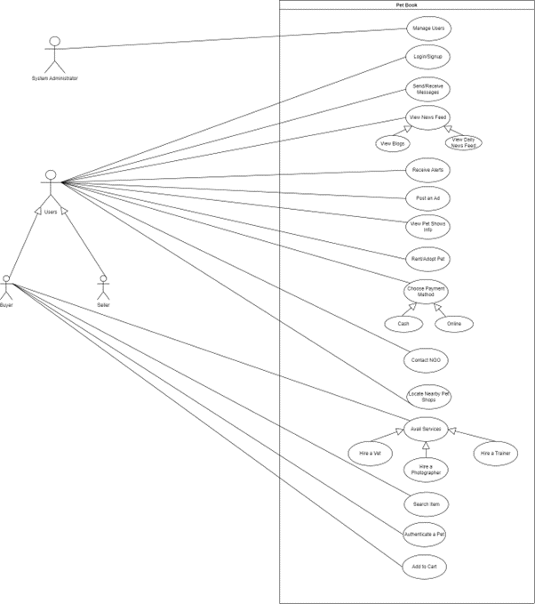

## High Level Use Case

## Manage Users

*Table 5: UC-01 Manage Users*

|  |  |
| --- | --- |
| **Use case ID** | 01 |
| **Use case Name** | Manage Users |
| **Actor** | System Administrator |
| **Type** | Primary |
| **Description** | The System Administrator manages the accounts of users. |

## Login/Signup

*Table 6: UC-02 Login/Signup*

|  |  |
| --- | --- |
| **Use case ID** | 02 |
| **Use case Name** | Login/Signup |
| **Actor** | Buyer, Seller |
| **Type** | Primary |
| **Description** | The Buyer/Seller would have to login into the system to continue using the application |

## Send/Receive Messages

*Table 7: UC-03 Send/Receive Messages*

|  |  |
| --- | --- |
| **Use case ID** | 03 |
| **Use case Name** | Send/Receive Messages |
| **Actor** | Buyer, Seller |
| **Type** | Primary |
| **Description** | The Buyer/Seller would be able to chat with each other. |

## View News Feed

*Table 8: UC-04 View News Feed*

|  |  |
| --- | --- |
| **Use case ID** | 04 |
| **Use case Name** | View News Feed |
| **Actor** | Buyer, Seller |
| **Type** | Primary |
| **Description** | The user would be able to view the different posts on his news feed. |

## Receive Alerts

*Table 9: UC-05 Receive Alerts*

|  |  |
| --- | --- |
| **Use case ID** | 05 |
| **Use case Name** | Receive Alerts |
| **Actor** | Buyer, Seller, System Administrator |
| **Type** | Primary |
| **Description** | The user will receive Alerts for awareness purposes. |

## Post an Ad

*Table 10: UC-06 Post an Ad*

|  |  |
| --- | --- |
| **Use case ID** | 06 |
| **Use case Name** | Post an Ad |
| **Actor** | Buyer, Seller |
| **Type** | Primary |
| **Description** | The user can post ads about anything related to pets. |

## View Pet Shows Info

*Table 11: UC-07 View Pet Shows Info*

|  |  |
| --- | --- |
| **Use case ID** | 07 |
| **Use case Name** | View Pet Shows Info |
| **Actor** | Buyer, Seller |
| **Type** | Primary |
| **Description** | The user will be able to check info on ongoing pet shows and also can organize his own pet show and post in this section. |

## Rent/Adopt a Pet

*Table12 : UC-08 Rent/Adopt a Pet*

|  |  |
| --- | --- |
| **Use case ID** | 08 |
| **Use case Name** | Rent/Adopt a Pet |
| **Actor** | Buyer, Seller |
| **Type** | Primary |
| **Description** | The Buyer/Seller would be able to rent their pets and get pet rent in exchange. |

## Choose Payment Method

*Table 13: UC-09 Choose Payment Method*

|  |  |
| --- | --- |
| **Use case ID** | 09 |
| **Use case Name** | Choose Payment Method |
| **Actor** | Buyer, Seller |
| **Type** | Primary |
| **Description** | The Buyer/Seller would be able to make/receive their payments. |

## Contact NGO

*Table 14: UC-10 Contact NGO*

|  |  |
| --- | --- |
| **Use case ID** | 10 |
| **Use case Name** | Contact NGO |
| **Actor** | Buyer, Seller |
| **Type** | Primary |
| **Description** | The Buyer/Seller would be able to get in contact with different NGOs. |

## Locate Nearby Pet Shops

*Table 15: UC-11 Locate nearby Pet Shops*

|  |  |
| --- | --- |
| **Use case ID** | 11 |
| **Use case Name** | Nearby Pet Shops |
| **Actor** | Buyer, Seller |
| **Type** | Primary |
| **Description** | The user would be able to locate the nearby pet shops. |

## Avail Services

*Table 16: UC-12 Avail Services*

|  |  |
| --- | --- |
| **Use case ID** | 12 |
| **Use case Name** | Avail Services |
| **Actor** | Buyer |
| **Type** | Primary |
| **Description** | The user would be able to avail the services of VET, Trainer, and a Photographer. |

## Search Item

*Table 17: UC-13 Search Item*

|  |  |
| --- | --- |
| **Use case ID** | 13 |
| **Use case Name** | Search Item |
| **Actor** | Buyer |
| **Type** | Primary |
| **Description** | The user would be able to search for different items. |

## Authenticate a Pet

*Table 18: UC-14 Authenticate a Pet*

|  |  |
| --- | --- |
| **Use case ID** | 14 |
| **Use case Name** | Authenticate a Pet |
| **Actor** | Buyer |
| **Type** | Primary |
| **Description** | The Buyer would check the authenticity of the pet he is going to buy. |

## Add to Cart

*Table 19: UC-02 Add to Cart*

|  |  |
| --- | --- |
| **Use case ID** | 15 |
| **Use case Name** | Add To Cart |
| **Actor** | Buyer |
| **Type** | Primary |
| **Description** | The user would be able to add different items to his cart that he intends to buy. |

## Expanded Use Case

## Login/Signup

|  |  |
| --- | --- |
| **Use case ID** | 02 |
| **Use case Name** | Login/Signup |
| **Actor** | Buyer, Seller |
| **Description** | The user would have to login into the system to continue using the application. |
| **Pre-Condition** | The user has installed the application |
| **Post Condition** | The user has logged in |
| **Normal Flow** | • Enter Username and password |
| **Alternative Flow** | • Authentication problem, request reset password  • Re-enter username and password |
| **Special**  **Requirement** | Availability of Internet |
| **Frequency of Use** | High |
| **Assumption** | The user knows how to login. |

## Manage Users

|  |  |
| --- | --- |
| **Use case ID** | 01 |
| **Use case Name** | Manage Users |
| **Actor** | System Administrator |
| **Description** | The System Administrator manages the accounts of users. |
| **Pre-Condition** | The system Administrator must be logged into the system. |
| **Post Condition** | The required changes must be made to the user accounts. |
| **Normal Flow** | 1. System administrator opens the application and enters login credentials. 2. System validates the credentials. 3. System grants access to the system administrator. 4. System administrator manages the account of the user when needed. 5. System saves the changes and returns a success message. |
| **Alternative Flow** | * The System administrator enters the login credentials.   • Login Credentials are incorrect.   * Error message is returned. |
| **Special**  **Requirement** | Availability of Internet |
| **Frequency of Use** | Normal |
| **Assumption** | The user intends to view other user’s profile to see their personal information |

## Send/Receive Messages

|  |  |
| --- | --- |
| **Use case ID** | 03 |
| **Use case Name** | Send/Receive Messages |
| **Actor** | Buyer, Seller |
| **Description** | The user would be able to communicate with each other by sending or receiving messages |
| **Pre-Condition** | The user must be logged in |
| **Post Condition** | A message would be sent, or old messages would be viewed |
| **Normal Flow** | • Click on the option of Messages  • Send a message to someone  • View Received replies |
| **Alternative Flow** | • Message can not be sent due to an internet problem  • Refresh and try again |
| **Special**  **Requirement** | Availability of Internet |
| **Frequency of Use** | Normal |
| **Assumption** | The user wants to send a message or view a received reply from any other user |

## Authenticate a Pet

|  |  |
| --- | --- |
| **Use case ID** | 14 |
| **Use case Name** | Authenticate a Pet |
| **Actor** | Buyer |
| **Description** | The Buyer would check the authenticity of the pet he is going to buy. |
| **Pre-Condition** | The Buyer must be logged in. |
| **Post Condition** | The buyer will successfully check the authenticity of the pet. |
| **Normal Flow** | • The buyer would log in and check for the pet Id of the pet he is willing to buy.  • The buyer will enter the Pet Id in the text box.  • The System will inform the user with a message whether the searched pet is authentic or not. |
| **Alternative Flow** | • The request cannot be sent due to internet problem.  • Refresh and try again |
| **Special**  **Requirement** | Availability of Internet |
| **Frequency of Use** | High |
| **Assumption** | The Buyer has the pet Id of the pet that he is looking to buy. |

## Post an Ad

|  |  |
| --- | --- |
| **Use case ID** | 06 |
| **Use case Name** | Post an Ad |
| **Actor** | Buyer, Seller |
| **Description** | The user can post ads about anything related to pets. |
| **Pre-Condition** | The user must be logged in. |
| **Post Condition** | A request to post an Ad would be sent to the admin. |
| **Normal Flow** | • Click on the button to post an Ad.  • Enter related information and skillset required for the job  • Request would be sent to the admin to post a job |
| **Alternative Flow** | • Request can not be sent due to an internet problem or the request has been declined by the admin.  • Refresh and try again |
| **Special**  **Requirement** | Availability of Internet. |
| **Frequency of Use** | High |
| **Assumption** | The user wants to post an Ad for other users to view. |

## Search Item

|  |  |
| --- | --- |
| **Use case ID** | 14 |
| **Use case Name** | Search Item |
| **Actor** | Buyer, Seller |
| **Description** | The user would be able to search for different items. |
| **Pre-Condition** | The Buyer must be logged in. |
| **Post Condition** | The buyer will be shown the desired search result if the items exist. |
| **Normal Flow** | • Buyer searches for an item.  • System gets the searched item from the database. |
| **Alternative Flow** | • System could not find the searched item from the database. |
| **Special**  **Requirement** | Availability of Internet |
| **Frequency of Use** | High |
| **Assumption** | The system has all the data relevant to the search. |

## Choose Payment Method

|  |  |
| --- | --- |
| **Use case ID** | 09 |
| **Use case Name** | Choose Payment Method |
| **Actor** | Buyer |
| **Description** | The user would be able to make his payments. |
| **Pre-Condition** | There must be some items in the cart. |
| **Post Condition** | The buyer successfully made his payments. |
| **Normal Flow** | • Buyer checks out.  • Buyer enters billing details.  • Buyer enters shipping details.  • Buyer confirms the order.  • Use case ends with a success. |
| **Alternative Flow** | • Not enough amount in the bank. |
| **Special**  **Requirement** | Availability of Internet |
| **Frequency of Use** | Normal |
| **Assumption** | The user must have a bank account. |

## 

## Domain Model

## Class Diagram

## Activity Diagram

## Layer Diagram

## Data Flow Diagram

## System Sequence Diagram

## Login/Signup

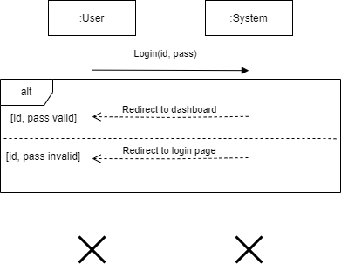

## Authenticate a Pet

## Search Item

## Choose Payment Method

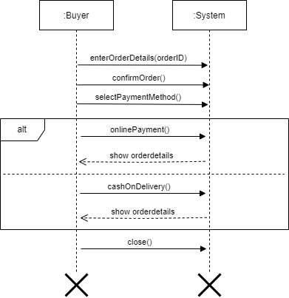

## Send/Receive Messages

## Manage User

## Sequence Diagram

